**Raymond You and Andrew Whitaker**

**Lab 5**

**EECE 2160 8 am – Kimani**

**Assignment 1**

a)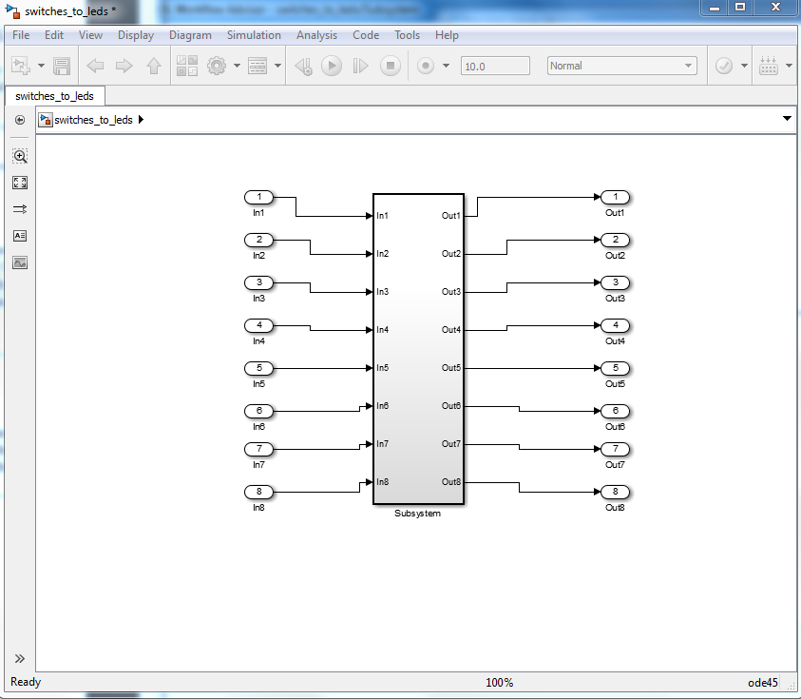

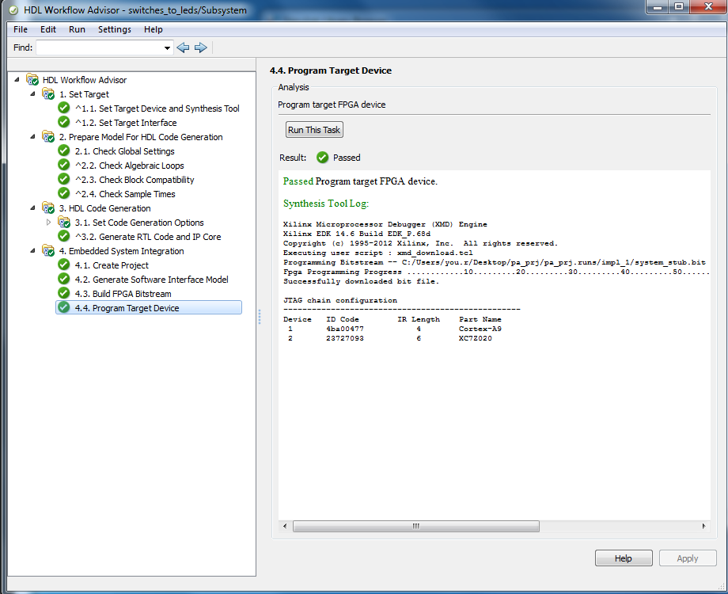b)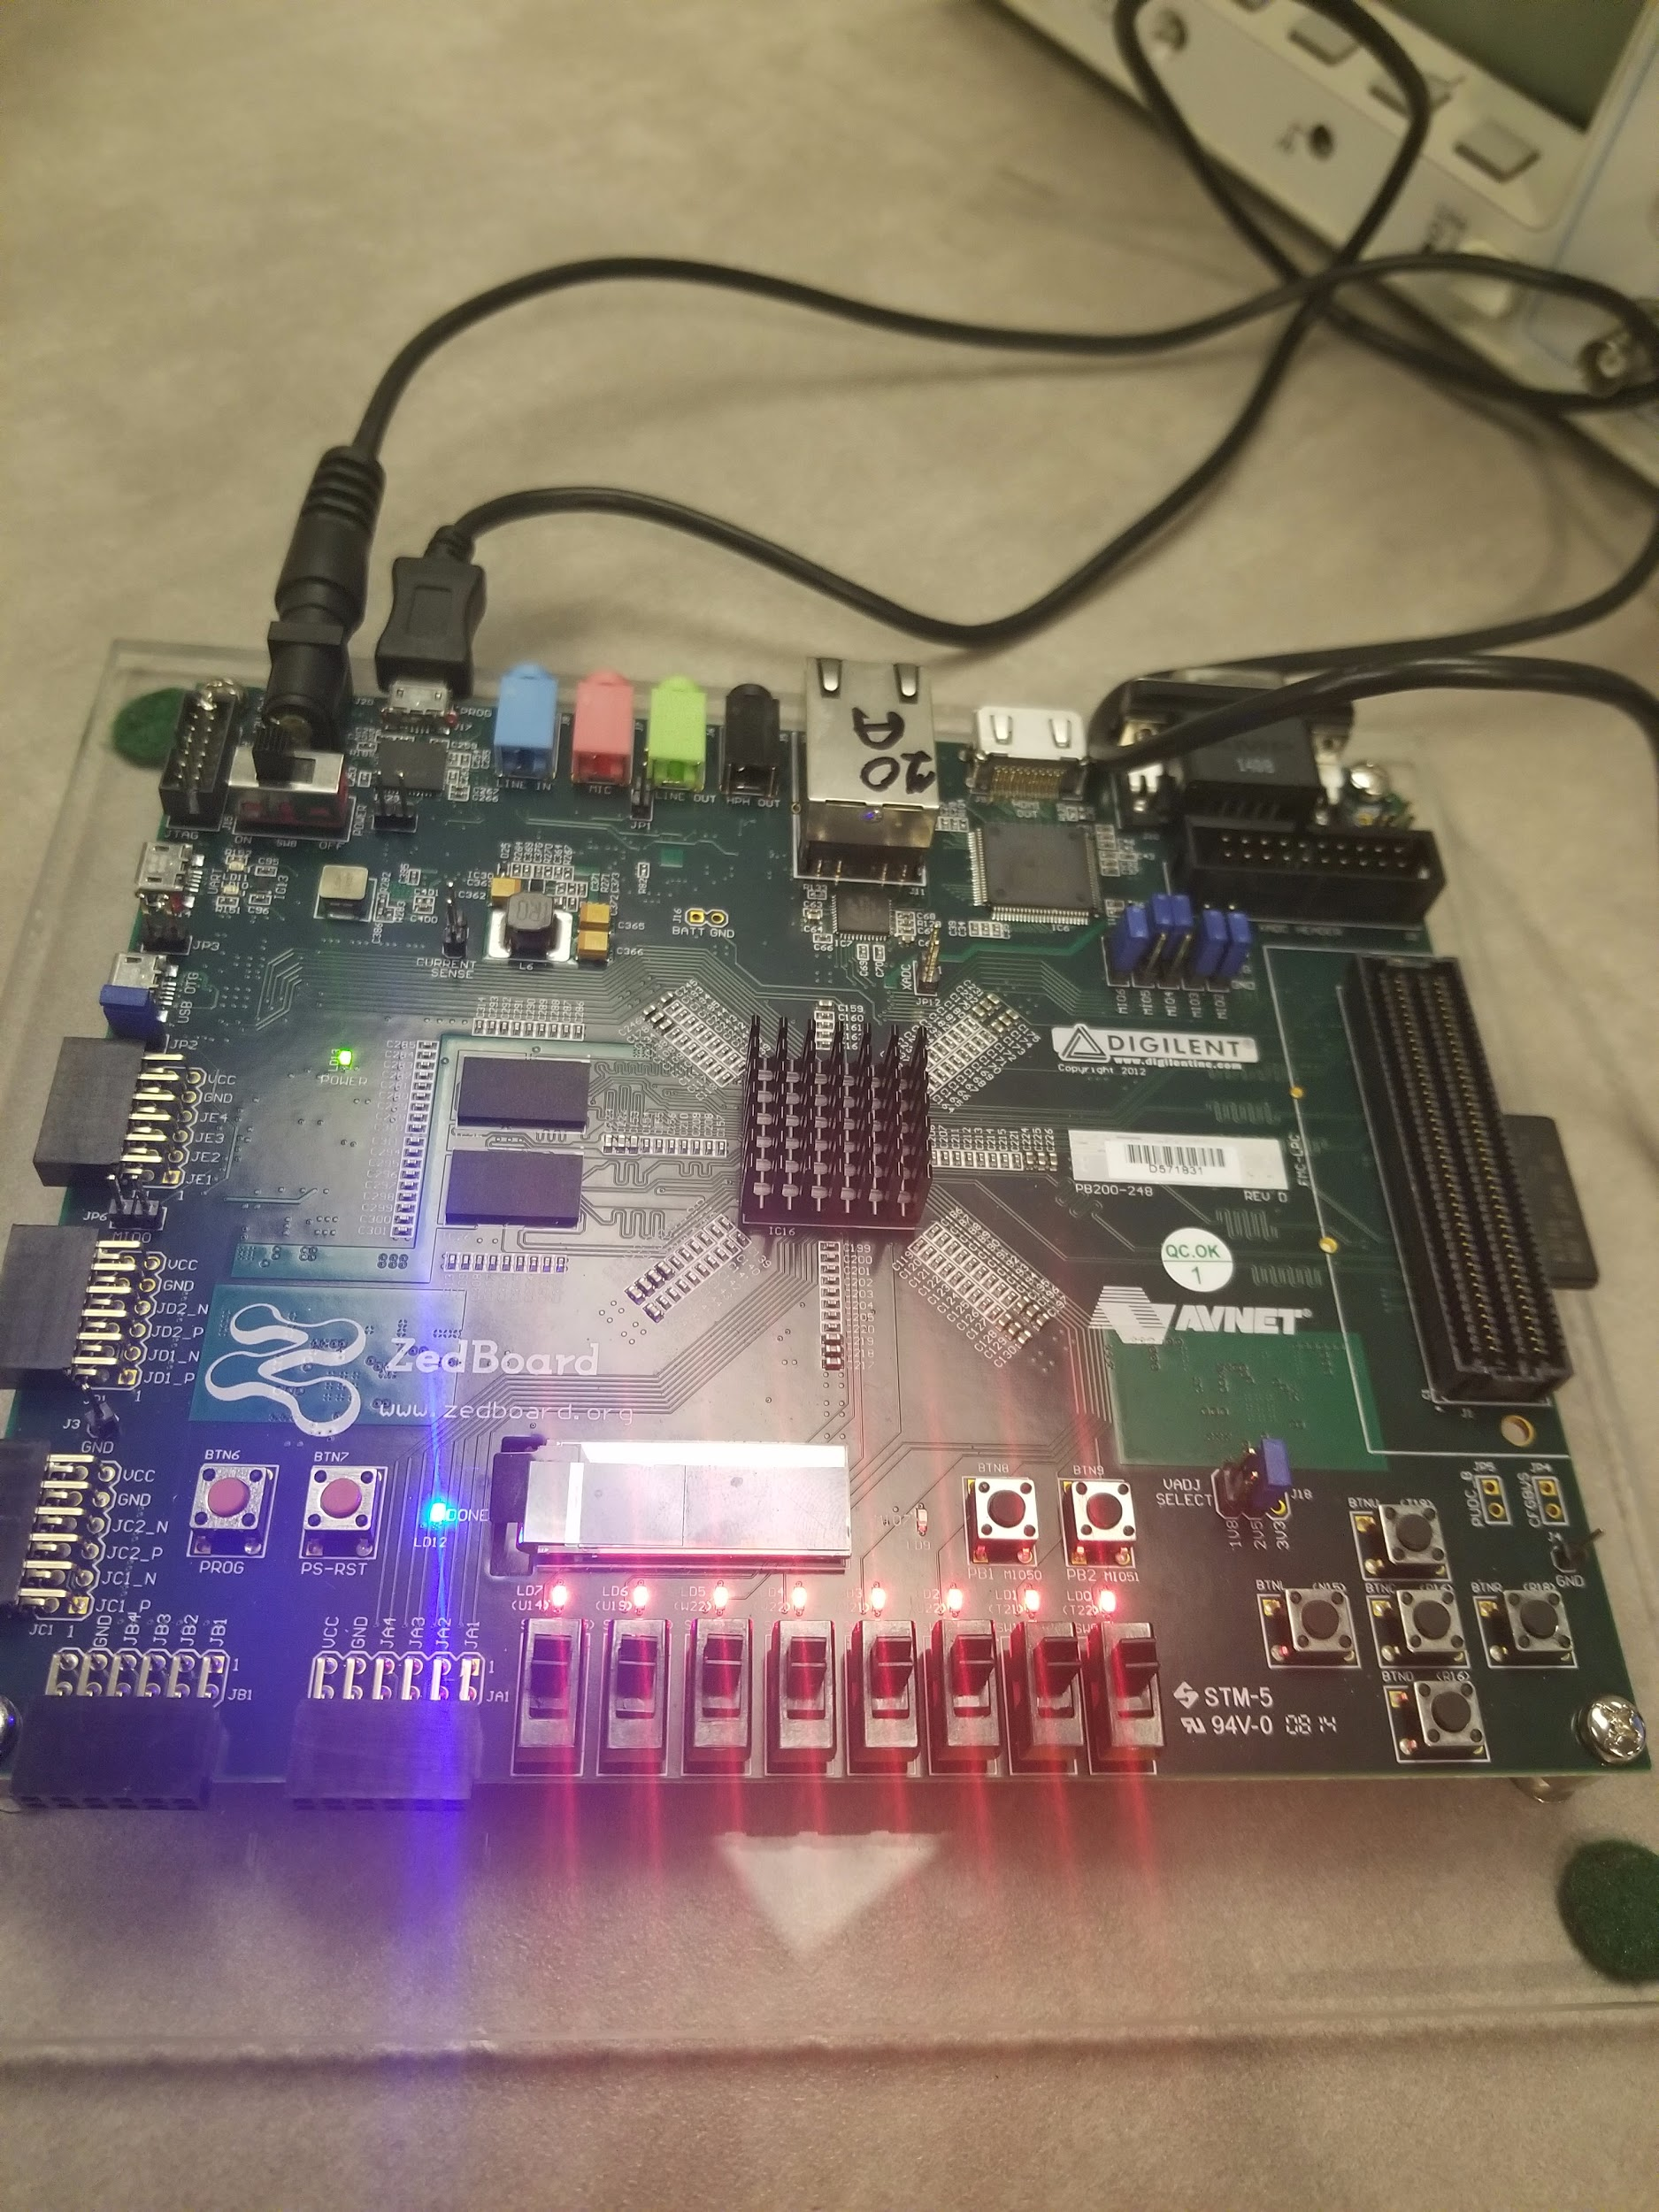

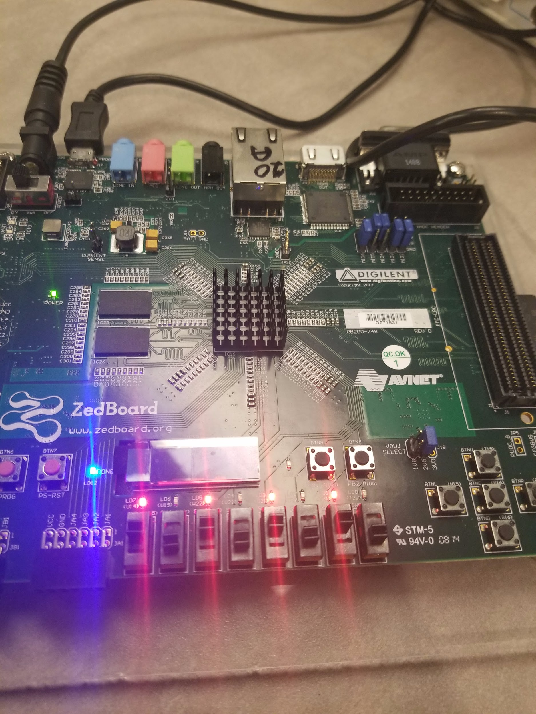

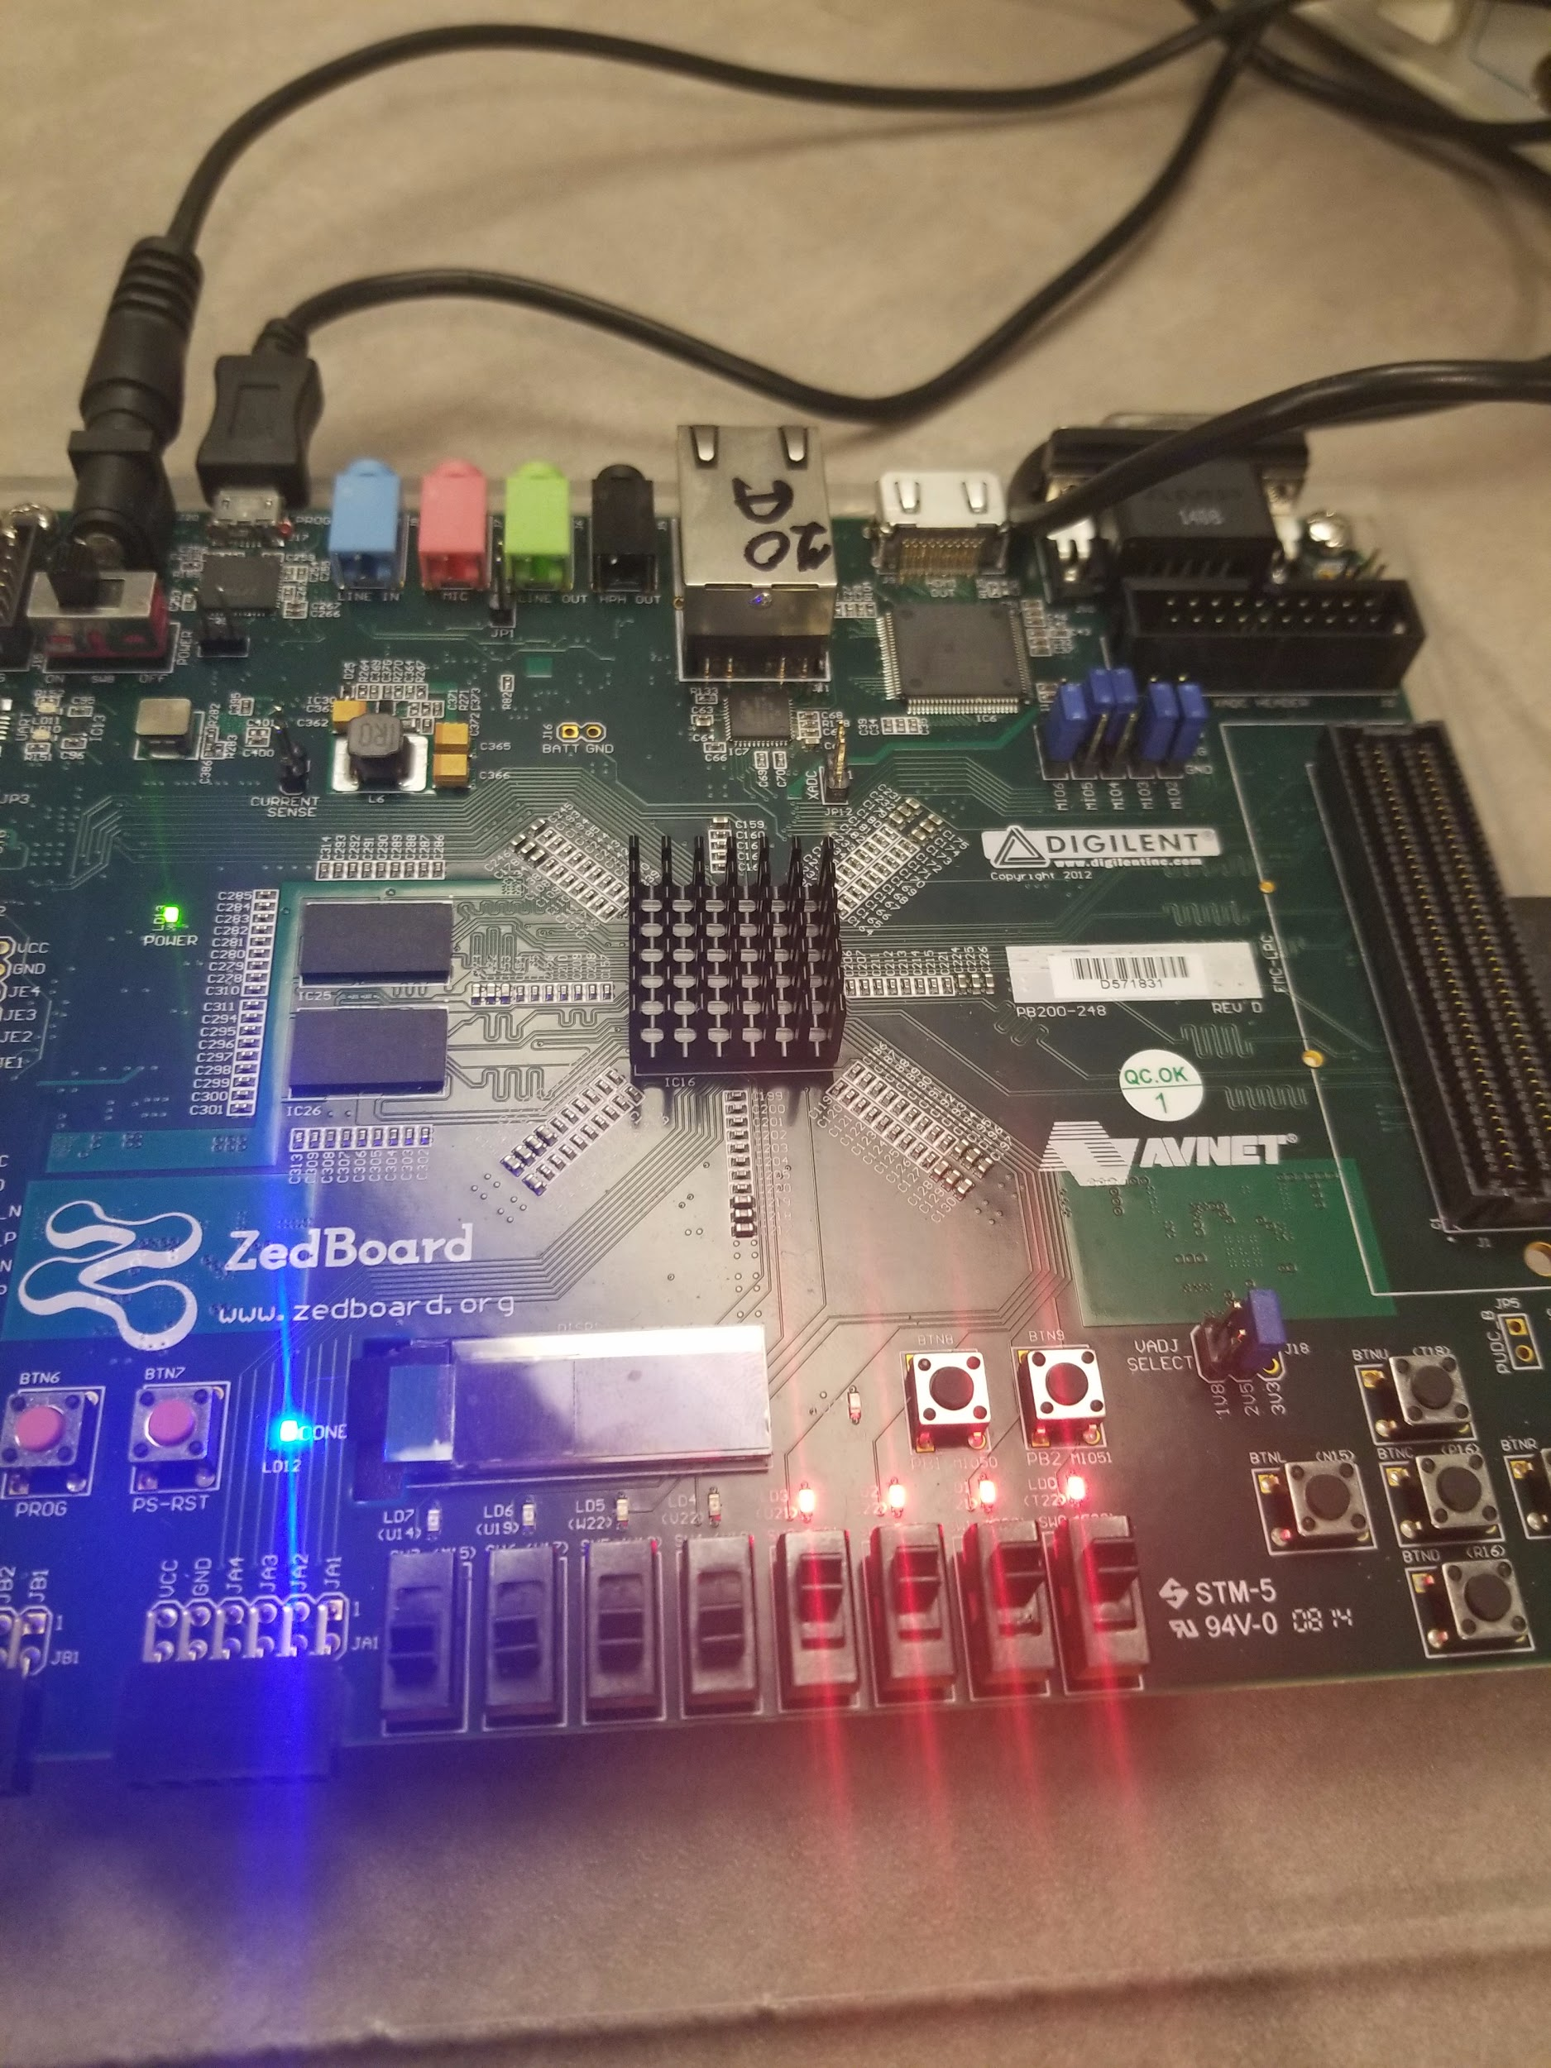

**Assignment 2**

a) 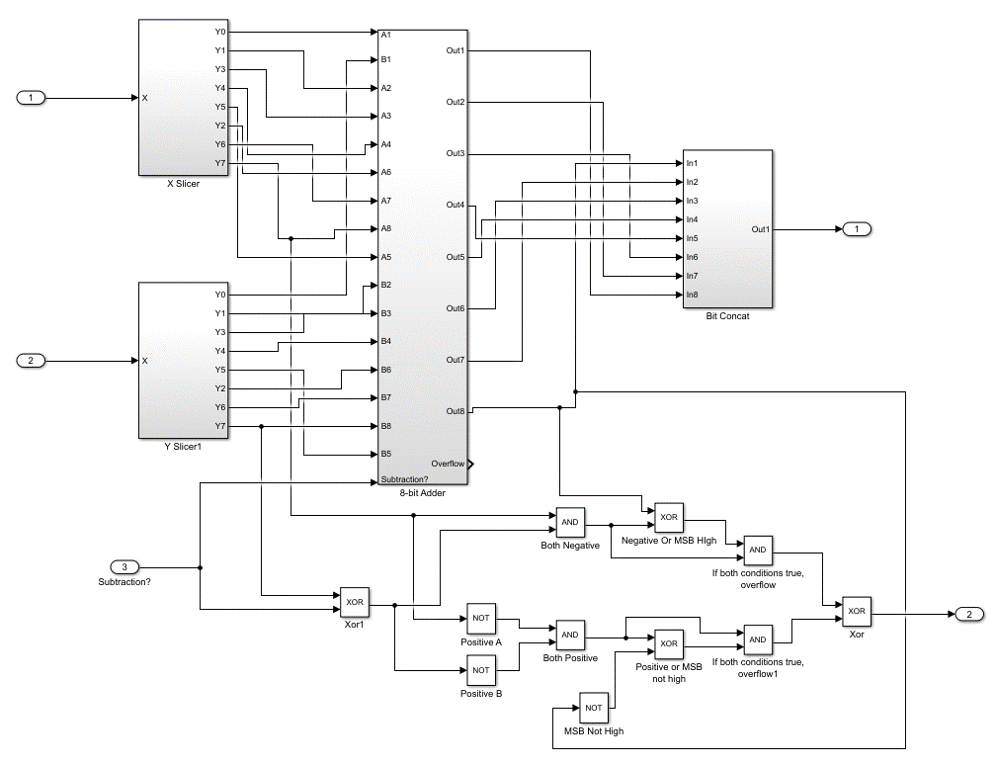

b)

addition:

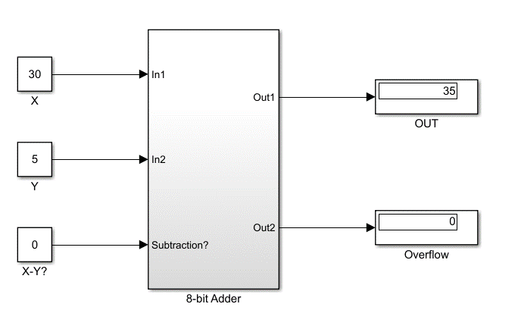Subtraction:

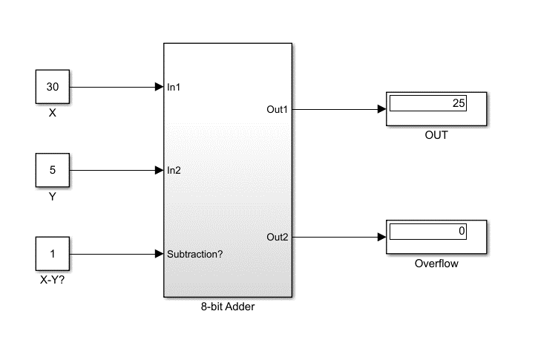

**Assignment 3**

a)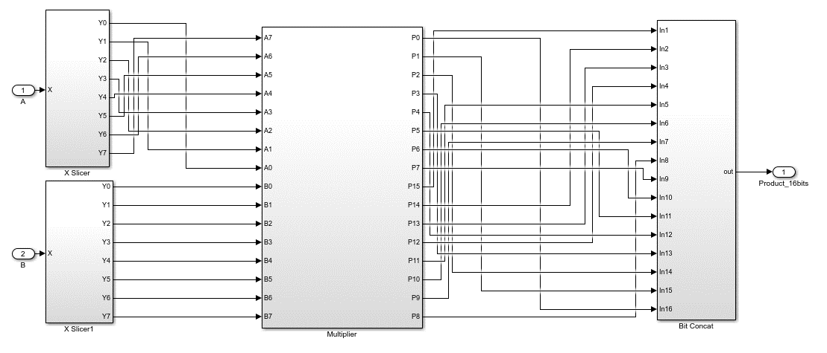

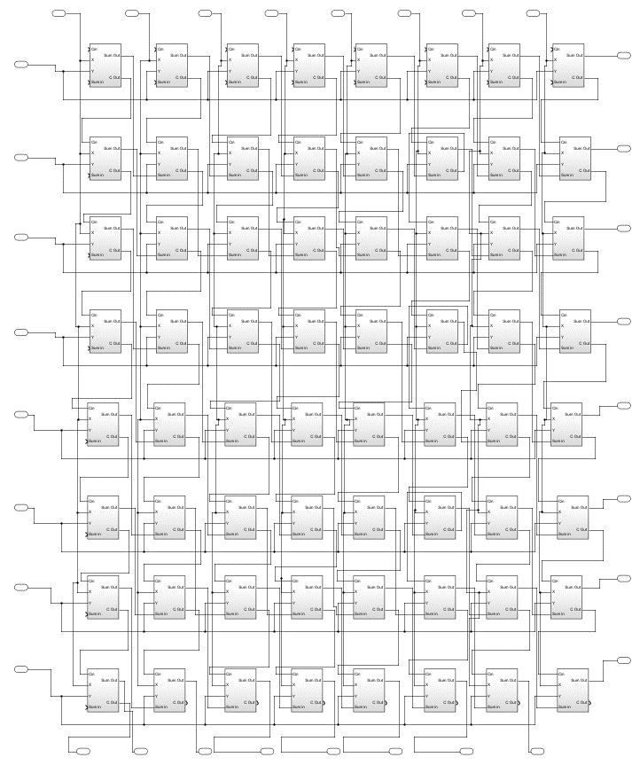

b)

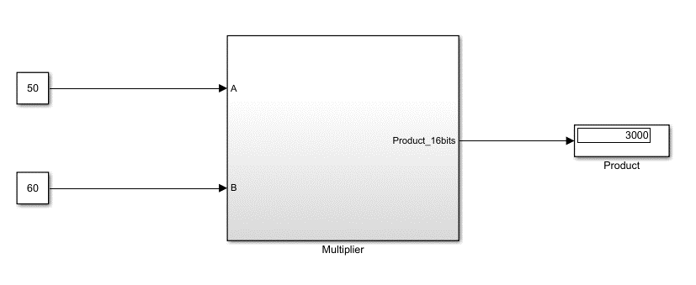

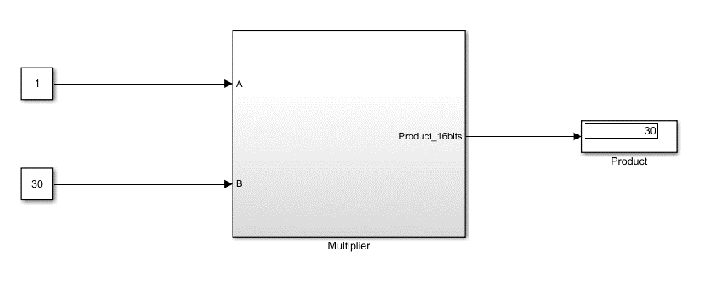

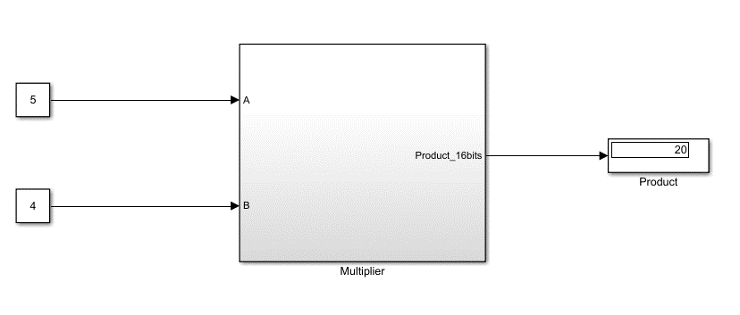

**Assignment 4**

a)

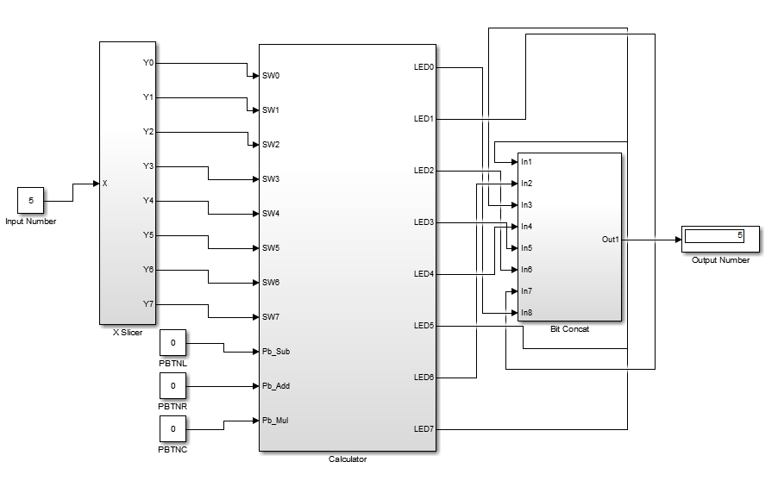

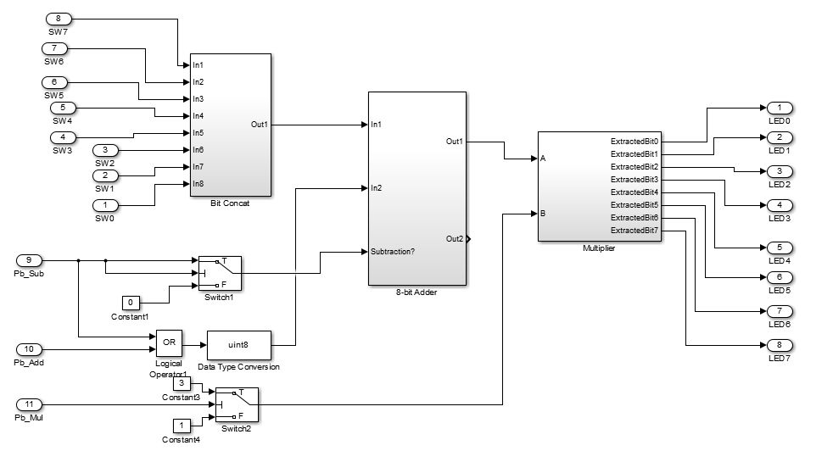

b)

**where only PBTNL is pressed**

5 - 1 = 4

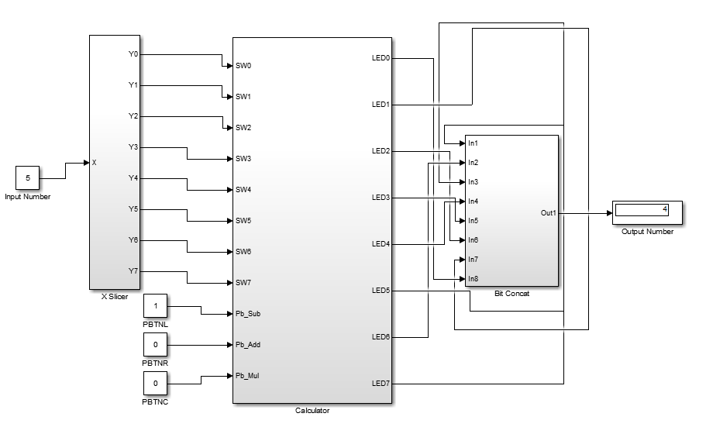

**where only PBTNR is pressed**

5 + 1 = 6

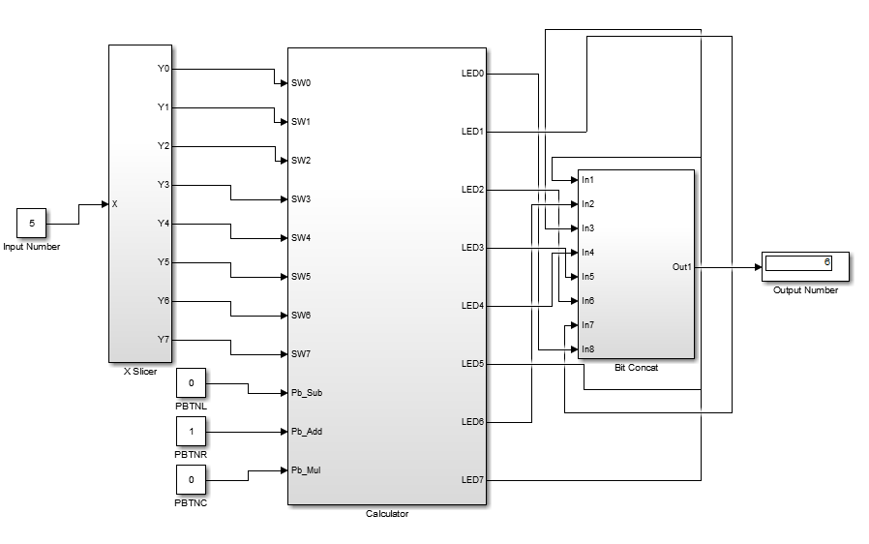

**where only PBTNC is pressed**

5 * 3 = 15

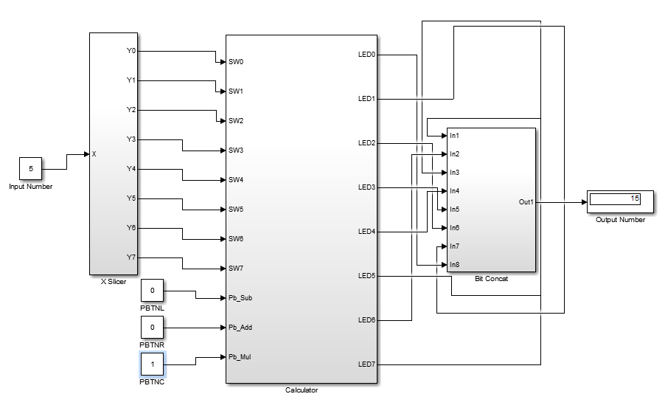

**where two of those push buttons are pressed**

1. 5 - 1 = 4
2. 4 * 3 = 12

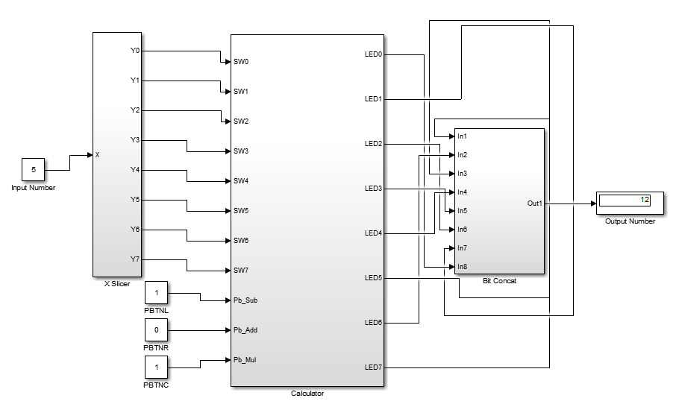

1. 5 + 1 = 6
2. 6 * 3 = 18

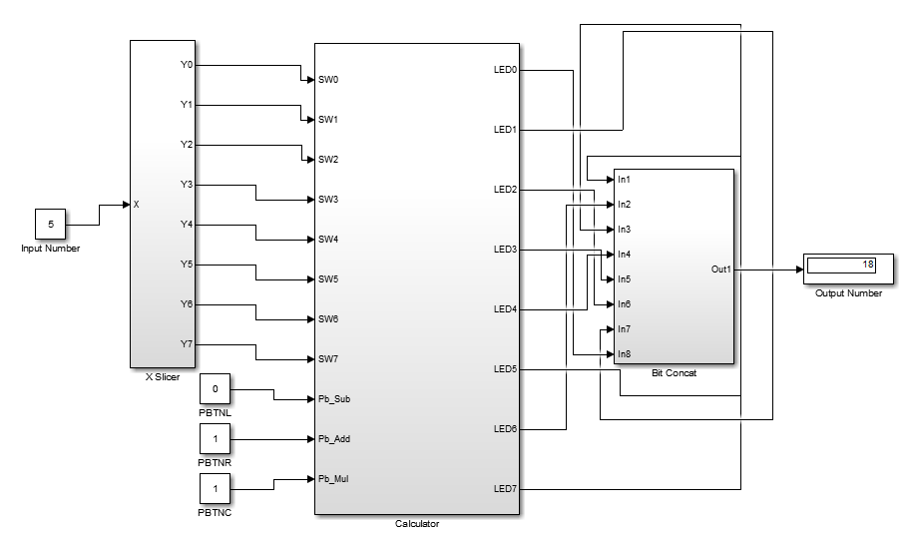

**Assignment 5**

Included in the video (turn sound on). In the video, 2 is the default number. When we pressed the left button, it becomes 1. When we pressed the right button, it becomes 3. When we pressed center button, it becomes 6. When we pressed center and right button, it became 9.